1. Biomass data was from Table 2 (page 173).

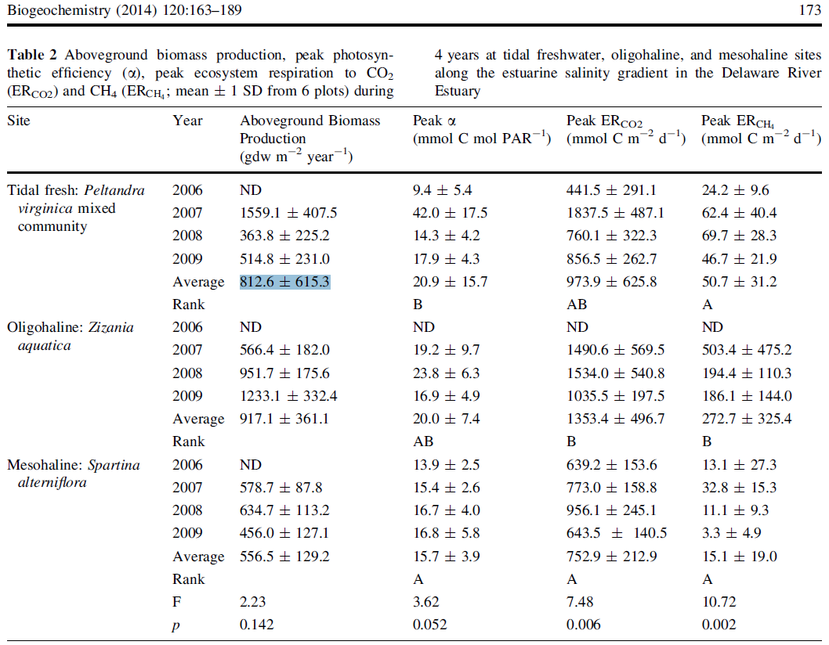

2. Marsh soil C data should be calculated from bulk density and organic C%. (Table 3)

Soil C pool = Bulk density \* Organic C%

It should be noted that data for site 1 was duplicated on both ‘marsh’ and ‘tidal fresh marsh’ tab from the master datasheet. We deleted the duplicate for marsh because the data from Table 2 shows the data was for tidal fresh marsh.

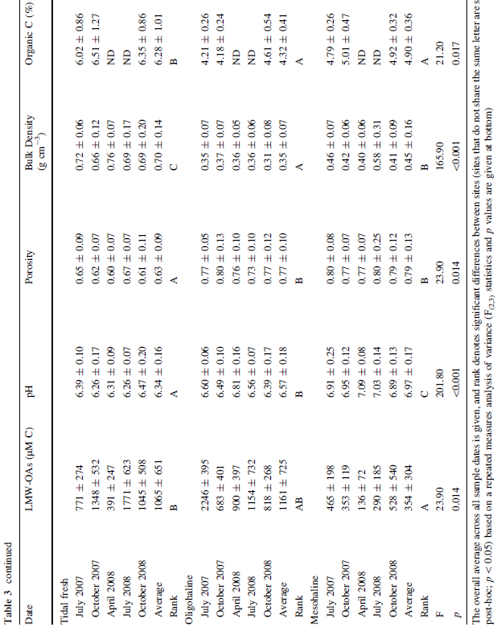

3. Soil C rate data was from Table 6.

